DATA COMMUNICATION AND COMPUTER NETWORKS LABORATORY ASSIGNMENT – 7
Name: Pulluru Sohan
Roll No: 120CS0125

Q1) Write Tcl script to create scenario and study the performance of token ring protocols through simulation. Create 6 nodes that forms a network numbered from 1 to 6. Create duplex links between the nodes to form a Ring Topology with bandwidth of 100 Mbps and delay of 2ms. Setup TCP Connection between node 1 and node 4. Apply FTP Traffic over TCP. Finish the transmission at 100 sec.
Ans:
set ns [new Simulator]
#Define different colours for data flow between nodes
$ns color 1 Blue
$ns color 2 Red
#Open the nam trace file
set nf [open out.nam w]
$ns namtrace-all $nf
#Define a 'finish' procedure
proc finish {} {
global ns nf
$ns flush-trace
#close the trace file
close $nf
#Execute nam on the trace file
exec nam out.nam &
exit 0
}
#Create 6 nodes
set n1 [$ns node]
set n2 [$ns node]
set n3 [$ns node]
set n4 [$ns node]
set n5 [$ns node]
set n6 [$ns node]
#Create links between the nodes
$ns duplex-link $n1 $n2 100Mb 2ms DropTail
$ns duplex-link $n2 $n3 100Mb 2ms DropTail
$ns duplex-link $n3 $n4 100Mb 2ms DropTail
$ns duplex-link $n4 $n5 100Mb 2ms DropTail
$ns duplex-link $n5 $n6 100Mb 2ms DropTail
$ns duplex-link $n6 $n1 100Mb 2ms DropTail
#Position of nodes
$ns duplex-link-op $n1 $n2 orient right-down
$ns duplex-link-op $n2 $n3 orient down
$ns duplex-link-op $n3 $n4 orient left-down
$ns duplex-link-op $n4 $n5 orient left-up
$ns duplex-link-op $n5 $n6 orient up
$ns duplex-link-op $n6 $n1 orient right-up

#Setup a TCP connection
set tcp [new Agent/TCP]
$tcp set class_ 1
$ns attach-agent $n1 $tcp

set sink [new Agent/TCPSink]
$ns attach-agent $n4 $sink
$ns connect $tcp $sink
#$tcp set fid_ 1

#Setup a FTP over TCP Connection
set ftp [new Application/FTP]
$ftp set packetSize_ 500
$ftp set interval_ 1
$ftp attach-agent $tcp
#$ftp set type_ FTP

$ns at 0.5 "$ftp start"
$ns at 10.0 "$ftp stop"
$ns at 100.0 "finish"
#Run the simulation
$ns run

Output:
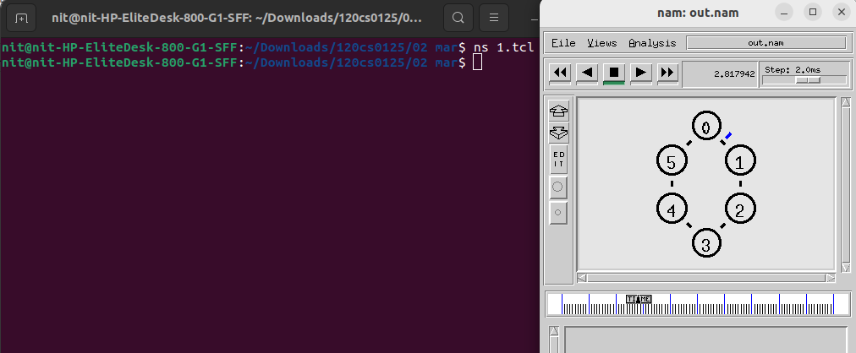

Q2) Write a Tcl script that forms a network consisting of 6 nodes, numbered from 1 to 6. Each of source and destination has bandwidth of 300 Mbps and delay of 20 ms. Set the bottleneck link bandwidth as 500 sec and delay 10ms. Set the routing protocol to Droptail. Define different colors for different data flows. Send TCP packet from node 1 to node 4 and UDP packet from node 5 to 6. Start the TCP data transmission at 1 sec and UDP at 15 sec. Finish the transmission at 100 sec. Then run nam to view the results.
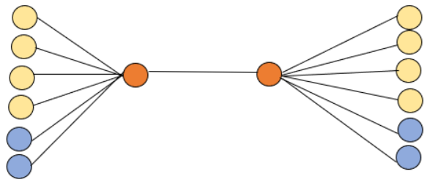
Calculate the following performance metrics using awk script:
a)Throughput
b)Delay
c)Packet loss ratio
d)Jain Fairness index.
e)Plot throughput graph using gnuplot(Tahoe vs Reno)
f)Plot Jain Fairness indexgraph using gnuplot
Ans:
#Lab 7 q2
set ns [new Simulator]
#Define different colours for data flow between nodes
$ns color 1 Blue
$ns color 2 Red
#Open the nam trace file
set nf [open out.nam w]
$ns namtrace-all $nf
#Define a 'finish' procedure
proc finish {} {
global ns nf
$ns flush-trace
#close the trace file
close $nf
#Execute nam on the trace file
exec nam out.nam &
exit 0
}
#Create 6 nodes
set n1 [$ns node]
set n2 [$ns node]
set n3 [$ns node]
set n4 [$ns node]
set n5 [$ns node]
set n6 [$ns node]
set n7 [$ns node]
set n8 [$ns node]
set n9 [$ns node]
set n10 [$ns node]
set n11 [$ns node]
set n12 [$ns node]
set n13 [$ns node]
set n14 [$ns node]
#Create links between the nodes
$ns duplex-link $n1 $n7 300Mb 20ms DropTail
$ns duplex-link $n2 $n7 300Mb 20ms DropTail
$ns duplex-link $n3 $n7 300Mb 20ms DropTail
$ns duplex-link $n4 $n7 300Mb 20ms DropTail
$ns duplex-link $n5 $n7 300Mb 20ms DropTail
$ns duplex-link $n6 $n7 300Mb 20ms DropTail
$ns duplex-link $n7 $n8 300Mb 20ms DropTail
$ns duplex-link $n8 $n9 300Mb 20ms DropTail
$ns duplex-link $n8 $n10 300Mb 20ms DropTail
$ns duplex-link $n8 $n11 300Mb 20ms DropTail
$ns duplex-link $n8 $n12 300Mb 20ms DropTail
$ns duplex-link $n8 $n13 300Mb 20ms DropTail
$ns duplex-link $n8 $n14 300Mb 20ms DropTail
#$ns duplex-link $n6 $n1 100Mb 2ms DropTail
#Position of nodes
#$ns duplex-link-op $n1 $n5 orient down

#Setup a TCP connection
set tcp1 [new Agent/TCP]
$tcp1 set class_ 1
$ns attach-agent $n1 $tcp1
set sink1 [new Agent/TCPSink]
$ns attach-agent $n9 $sink1
$ns connect $tcp1 $sink1
#$tcp set fid_ 1

set tcp2 [new Agent/TCP]
$tcp2 set class_ 2
$ns attach-agent $n2 $tcp2
set sink2 [new Agent/TCPSink]
$ns attach-agent $n10 $sink2
$ns connect $tcp2 $sink2
#$tcp set fid_ 1

set tcp3 [new Agent/TCP]
$tcp3 set class_ 3
$ns attach-agent $n3 $tcp3
set sink3 [new Agent/TCPSink]
$ns attach-agent $n11 $sink3
$ns connect $tcp3 $sink3
#$tcp set fid_ 1

set tcp4 [new Agent/TCP]
$tcp4 set class_ 4
$ns attach-agent $n4 $tcp4
set sink4 [new Agent/TCPSink]
$ns attach-agent $n12 $sink4
$ns connect $tcp4 $sink4
#$tcp set fid_ 1

#Setup a FTP over TCP Connection
set ftp1 [new Application/FTP]
$ftp1 set packetSize_ 500
$ftp1 set interval_ 1
$ftp1 attach-agent $tcp1
#$ftp set type_ FTP

set ftp2 [new Application/FTP]
$ftp2 set packetSize_ 500
$ftp2 set interval_ 1
$ftp2 attach-agent $tcp2
#$ftp set type_ FTP

set ftp3 [new Application/FTP]
$ftp3 set packetSize_ 500
$ftp3 set interval_ 1
$ftp3 attach-agent $tcp3
#$ftp set type_ FTP

set ftp4 [new Application/FTP]
$ftp4 set packetSize_ 500
$ftp4 set interval_ 1
$ftp4 attach-agent $tcp4
#$ftp set type_ FTP

set udp5 [new Agent/UDP]
$ns attach-agent $n5 $udp5
set null5 [new Agent/Null]
$ns attach-agent $n13 $null5
$ns connect $udp5 $null5

#Setup a CBR over UDP connection
set cbr5 [new Application/Traffic/CBR]
$cbr5 attach-agent $udp5
$cbr5 set type_ CBR
$cbr5 set packet_size_ 10000

set udp6 [new Agent/UDP]
$ns attach-agent $n6 $udp6
set null6 [new Agent/Null]
$ns attach-agent $n14 $null6
$ns connect $udp6 $null6

#Setup a CBR over UDP connection
set cbr6 [new Application/Traffic/CBR]
$cbr6 attach-agent $udp6
$cbr6 set type_ CBR
$cbr6 set packet_size_ 10000

$ns at 1.0 "$ftp1 start"
$ns at 1.0 "$ftp2 start"
$ns at 1.0 "$ftp3 start"
$ns at 1.0 "$ftp4 start"
$ns at 15.0 "$cbr5 start"
$ns at 15.0 "$cbr6 start"
$ns at 100.0 "finish"
#Run the simulation
$ns run

Output:
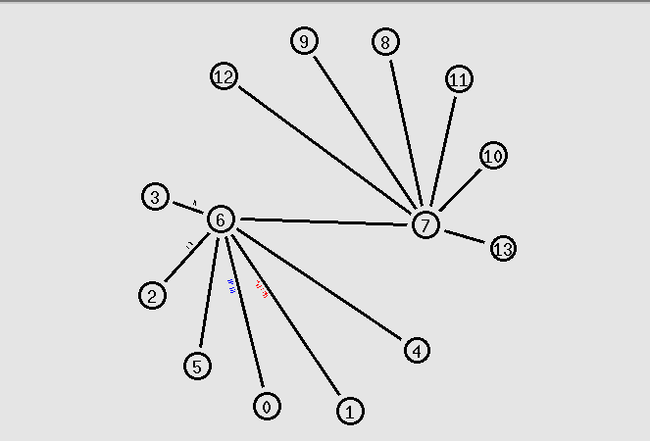
We can see tcp packets in above picture
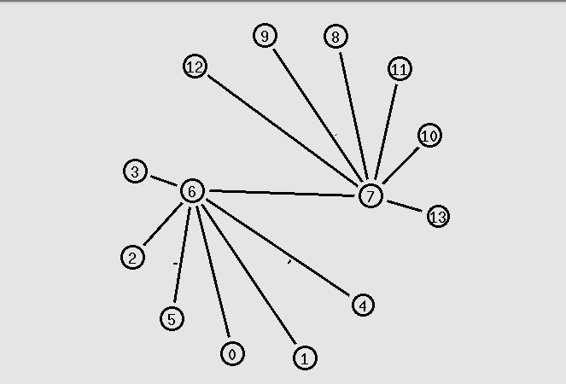
We can see UDP packets in above picture

